ROCK into
New Years Eve 2007

Featuring live music by:
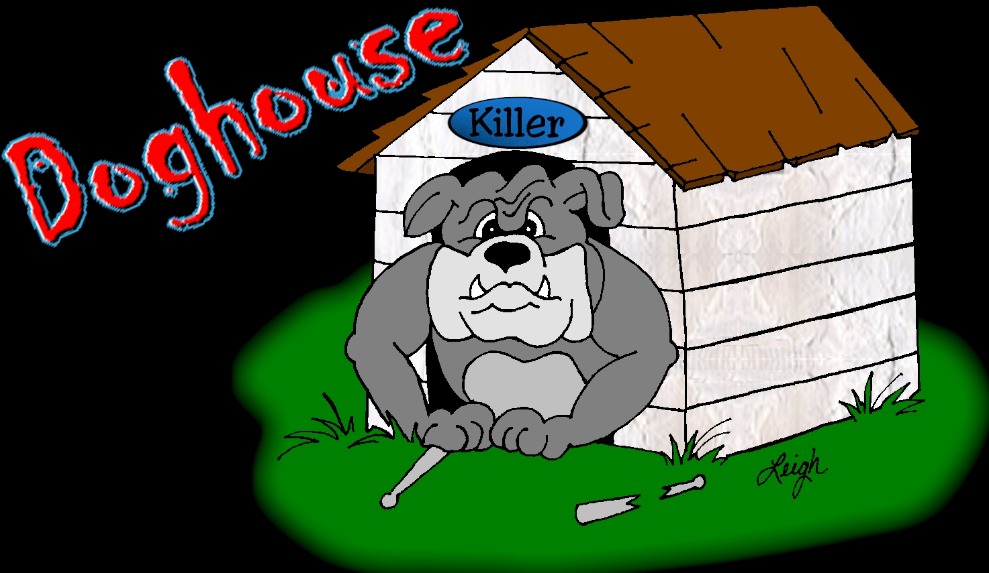
2007 World Tour

St. Timothy Parish- Brodnick Hall

7:00 P.M. – 1:00 A.M.
$45.00 Single
$85.00 Couple

- Hot dinner served from 7:30 P.M. to 9:00 P.M.
- Open bar – Serving beer, wine, bourbon + set-ups
- Champagne toast at midnight

Contact:
- Dawn/Chris Leedom 525-6755 or
- Mike/Eileen Fiedler 371-1463

BENGALS GAME WILL BE PROJECTED LARGE SCREEN IF PLAYING!

